Building Coalitions To Promote Health Equity: A Toolkit for Action

Acknowledgments
We appreciate the review and contributions of the Campaign for Action’s Equity, Diversity, and Inclusion Steering Committee: Carmen Alvarez, PhD, CRNP, CNM, FAAN, Norma Cuellar, PhD, RN, FAAN, Martha Dawson, DNP, RN,FACHE, Mary Joy Garcia-Dia, DNP, RN, FAAN, Sandy Littlejohn, MA, BSN, RN, Blake K. Smith, MSN, RN and Eric J. Williams, DNP, RN, FAAN; and the overall guidance and contributions of Winifred V. Quinn, PhD, FAANP (H) and Scott Tanaka, MSW, at the Center to Champion Nursing in America at AARP, an initiative of AARP Foundation, AARP and the Robert Wood Johnson Foundation.

Authors
Kupiri Ackerman-Barger, PhD, RN, FAAN, Jazmine Cooper, MBA, Regina Eddie, PhD, RN, Claudio Gualtieri, JD, Lisa Martin, PhD, RN, FAAN, Barbara Nichols, MS, RN, FAAN, and G. Adriana Perez, PhD, CRNP, FAAN

Table of Contents

Section 1: Overview and Purpose
Section 2: Understanding Upstream and Downstream Care
Section 3: Assessing Your Knowledge and Preparedness
Section 4: Community Assessment
Section 5: Social Diagnosis/Deciding
Section 6: Planning
Section 7: Action/Implementation
Section 8: Evaluating Impact
Section 9: Resource Hub
Section 10: About the Authors
References

Section 1. Overview and Purpose
Building a Culture of Health and Promoting Health Equity: A Toolkit for Action

Purpose: The purpose of the toolkit is to provide action-based strategies and concrete steps for individuals, communities, and health care facilities to promote and sustain a Culture of Health (see definition on Page 14). By sharing resources and examples of communities in action, we hope to facilitate community dialogue and meaningful partnerships that result in the identification of collective health goals that inspire concrete actionable community initiatives that improve health outcomes.

The Mission
The Future of Nursing: Campaign for Action’s Equity, Diversity, and Inclusion Steering Committee works to identify advocates and leaders to implement policies, programs, and best and promising practices to ensure a diverse cadre of nurses; and to promote health equity and address systemic and institutional racism and other inequities for historically marginalized populations.

CampaignforAction.org

Who the toolkit is for: Building Coalitions To Promote Health Equity: A Toolkit for Action, from the Center to Champion Nursing in America (CCNA), is for nurses and interprofessional colleagues to help in efforts to address social determinants of health (SDOH) and to advance health equity in their communities.

Of all health care providers, it is nurses who spend the most time by far with patients and their families in their communities, and so—given their training—understand the factors that affect people’s lives. For that reason, nurses in all practice settings, including communities, primary care, and health care systems, are uniquely poised to lead the way in tackling many of the health crises and health disparities in the United States (Hassmiller, 2019).

Many nurses are working to promote health equity, and they fill an important role. As well as working together from many distinct practice settings, nurses need to work collaboratively with interprofessional teams and partners within and beyond health care systems. This includes in particular community leaders and organizations, who best understand their own community health issues and solutions. These partnerships create a way to take action on SDOH and move toward improving health equity. Therefore, the toolkit is for nurses and all health care providers, community members, health care stakeholders, businesses, health care facilities, consumer advocates, philanthropists, and anyone interested in creating meaningful health and health care changes toward achieving a Culture of Health in their community.

How to use the toolkit: CCNA’s Building Coalitions To Promote Health Equity: A Toolkit for Action provides step-by-step instructions on how to find and engage partners, stakeholders, and potential funders to address health equity and develop an action plan that addresses SDOH and advances health equity in their communities. Each section is a stand-alone and it is best to start with the section that most applies to your coalition’s needs.

This toolkit begins with an overview of SDOH for those not familiar with the social determinants of health factors.

How to navigate the toolkit: CCNA’s Building Coalitions To Promote Health Equity: A Toolkit for Action is organized using the acronym ADPIE, which includes the five steps in the nursing process: Assessment, Diagnosis, Planning, Implementation, and Evaluation. ADPIE is a framework that helps individuals make sense out of complexity. Nurses, other health professionals, and community leaders with all levels of education will understand this universal language and framework to assess their communities’ needs and their organizational readiness to take action on SDOH and health equity.

(Although ADPIE provides a linear way to ensure that steps are not missing, in nursing, nothing is ever linear—indeed, we work in 3D in everything we do.)

This, Section 1, provides an overview of the toolkit. Sections 2, 3, and 4 include tools and recommendations for ways to gather community ideas and data to decide priority areas—leading to Section 5, social diagnosis. Sections 6 and 7 emphasize overall and action planning and include communication and fundraising resources. Section 8 provides guidance on evaluating the Action Coalition's efforts to address SDOH and the impact on policy, community health/behavior change outcomes, and potential for sustainability and replication. Section 9 provides links to all resources included throughout the toolkit.

Each section includes descriptions and definitions introducing topics, current evidence or best practices, and resources, including interactive webinars to inspire action. We recommend starting with Sections 1 through 3, which includes an SDOH survey to assess nurses’ knowledge, readiness, and willingness and capacity to take action on SDOH in their practice setting. Based on the results, you should consider reviewing the webinars and references offered for those who need more information, including Susan Hassmiller’s “Perfectly Positioned: Galvanizing Nurses To Address the Social Determinants of Health.” If ready, move to Sections 4 through 8, which include planning and select topics of interest. Finally, check out the Resource Hub, which includes examples of communities in action, helpful tools (e.g., communication, advocacy), author biographies (see Section 10), and references.

Section 2. Understanding Upstream and Downstream Care

Public health nurses advocate focusing on a continuum of health that includes individuals, communities, and systems (Schaffer & Strohschein, 2019). Many scholars argue that a primary focus on the individual and point-of-contact care distracts us from understanding the root causes of health outcomes, which begin with community health and systemic and structural inequities. An analogy of a stream has been used to describe this process. A downstream focus on care means attending first to patients when they present in primary care, emergency rooms, or hospitals. A midstream approach looks at social need, while understanding SDOH and the systems and structures that continuously produce the same outcomes over time is a more upstream approach. For more information on the upstream/downstream analogy see the following links: Castrucci & Auerbach, 2019; Manchanda TED Talk, 2014; Jones, 2014.

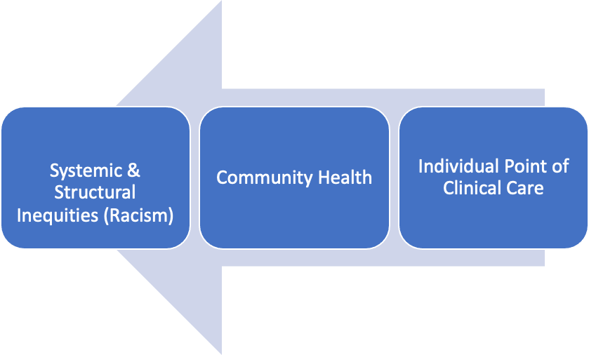

Upstream
Downstream

Figure 1: Understanding Health Disparities From an Upstream/Downstream Analogy

- Health disparities exist when a health outcome “is seen to a greater or lesser degree between populations.” They are “particular types of health differences that are closely linked with social, economic, and/or environmental disadvantage. Health disparities adversely affect groups of people who have systematically experienced greater obstacles to health based on their racial or ethnic group; religion; socioeconomic status; gender; age; mental health; cognitive, sensory, or physical disability; sexual orientation or gender identity; geographic location; or other characteristics historically linked to discrimination or exclusion” (Healthy People 2020). The cause of health disparities is neither simple nor singular, but rather a combination of inequities that occur structurally, institutionally, and through individual interactions. Health disparities are an important metric for understanding health outcomes.

- Unmet social needs contribute to disparate health outcomes. If the health outcome is what we see during a patient visit, the social need can become more apparent through social needs screening, where it can become apparent that an individual, family, or community lacks access to a resource (food, transportation, ability to pay for medication, etc.) that would otherwise contribute to a better health outcome. It is useful to understand what a patient, family, or community needs, but we also must understand how these needs manifest and how they determine health.

- Social determinants of health can be defined as factors that contribute to health or illness. These can include the environments in which people are born, grow, live, learn, work, play, worship, and age that affect a wide range of health, functioning, and quality of life outcomes and risks ( Healthy People 2020). Understanding health disparities can provide vital contextual information about health disparities (see Figure 1 and Table 1).

Figure 2. Social Determinant Factors, Adapted From Healthy People 2020

- Systemic and structural inequalities can be considered the root cause of many of the health disparities we see. These include laws, policies, wealth imbalances, political and social influences, redlining and zoning laws, rural and urban infrastructures, and access to resources such as health care, food, housing, and education. Metzl and Hanson (2014) argued that in order to improve health outcomes, health care providers need to be as versed in “structural” competencies as they are in physical assessment, diagnostics, and point-of-care interventions.

Table 1: Social Determinants and Health Impact
Below is a table of examples of social determinants of health. This is not an exhaustive list, but rather an introduction to five key factors (see figure above) identified by Healthy People 2020, as well as some SDOH that are emerging, such as adverse childhood experiences, discrimination and racism, and social isolation.

Social Determinant | Definition | Health Impact
Economic Stability
Housing Insecurity (Housing Instability) | Housing insecurity is characterized by eviction, homelessness, living in a motel or hotel, frequent moving, or living in crowded conditions. | Housing insecurity is related to chronic disease, poor health, and impeded access to and delayed clinic visits. (Healthy People 2020–Housing Insecurity.)
Food Insecurity | Food insecurity occurs when there is insufficient nutritional intake due to lack of money or resources. Hunger may or may not be present with food insecurity. | People who are food insecure are at higher risk for obesity. Children who are food insecure are more likely to experience developmental problems and mental health issues. (Healthy People 2020–Food Insecurity; Compton and Shim, 2015.)
Unemployment, Low Income, and  Poverty | Disparities exist in the workforce. Related to both race/ethnicity and gender, leading to disproportionate low-income status and financial struggles for minorities and women. Poverty is often thought of as extreme low income; however, to truly understand poverty, it needs to be examined through the lens of a deprivation of resources and opportunity. | Unemployment, low income, and poverty Create hardship that can result in depression, anxiety, stress, and physical pain. The risk for chronic conditions such as heart disease, diabetes, and obesity is higher among those with the lowest income. In addition, older adults who are poor experience higher rates of disability and mortality. Finally, people with disabilities are more vulnerable to the effects of poverty than are other groups.  (Healthy People 2020–Employment.)
Education
Early Childhood Development and Adverse Childhood Experiences (ACEs) | Early childhood affects long-term cognitive and physical development. ACEs are defined as physical, emotional, or sexual abuse, emotional or physical neglect, and household dysfunction. | ACEs correlate to negative physical and mental health outcomes. This emerging science recognizes that stress in the absence of support is responsible for pervasive and lasting changes in brain anatomy, physiology, and behavior. (Compton and Shim, 2015; Felitti, et al., 1998.)
Elementary School | The quality of elementary school education can vary from neighborhood to neighborhood. High-quality schools should be able to offer comprehensive education with low teacher-to-student ratios, school meals, and access to health and social services. | Because of the essential role of early childhood development, the quality of elementary school education can affect short- and long-term health. (Healthy People 2020–Education.)
High School Graduation | A high school diploma is needed for many jobs and for enrollment in higher education. However, disparities in high school graduation (race/ethnicity, socioeconomic status, LGBTQ, etc.) exist across demographic groups and geographic location. | There is evidence that students who drop out of high school are at risk for poor health outcomes and premature death. (Healthy People 2020–Education.)
Higher Education | A college degree can improve employment opportunities, and therefore improve food, housing, and health care resources, too. | Higher education can lead to improved health and well-being. (Healthy People 2020–Education.)
Health and Health Care
Access to Care | Access to care relates to factors such as lack of insurance or ability to pay; availability of providers; and fragmented services and difficulty navigating services. This can be particularly difficult in rural areas. | Poor access to care leads to poor physical and mental health outcomes, increased morbidity, and early death. (Healthy People 2020–Access to Health Services.)
Neighborhood and Built Environment
Neighborhood Deprivation | Neighborhood deprivation refers to a lack of local resources, which can include access to health care, schools, work, and high-quality food. It can also include the built environment. That includes the amount of green space, parks, and walkable areas, as well as the design of the community, which can create overcrowding, noise, and poor lighting. | Residents of impoverished neighborhoods or communities are at increased risk for mental illness, chronic disease, higher mortality, and lower life expectancy.  (Healthy People 2020–Environmental Conditions.)
Environmental Contamination | Exposure to pollution, toxins, pests, contaminated water, or physical hazards can affect population health. | Exposure to environmental contamination is associated with higher rates of cardiovascular disease, hypertension, asthma, cancer, and waterborne illnesses, as well as hindered fetal and child development.  (Healthy People 2020–Environmental Conditions.)
Transportation | Transportation refers to the ability of individuals and families to travel to places needed to obtain resources, including healthy food, quality education, employment, health care services, utilities, etc. This is particularly problematic for people in locations that lack public transportation (rural and many urban areas) and for those who do not have a reliable mode of personal transportation. | The impact of lack of transportation is diminished access to resources. In the health care setting, this can result in missed appointments, lack of preventive care follow-up care (e.g., perinatal care or well-child visits).
Crime and Violence | Exposure to violence could be direct or indirect by being a witness to or hearing about crime in their communities. | Repeated exposure may be linked to increased negative health outcomes. For example, people who feel less safe because of fear of crime and violence are less likely to engage in physical activity, which can lead to obesity.  (Healthy People 2020–Crime and Violence.)
Social and Community Context
Discrimination and Racism | Discrimination can occur in many forms, including reactions to race/color/ethnicity, age, gender, sexual orientation, or gender identity. Thirty-one percent of U.S. adults experience one major discriminator event in their lifetime, whereas 63% of U.S. adults report discrimination every day. Although race is largely understood now to be a sociological and not biological construct, according to the Human Genome Project findings, experiencing racism is a risk factor for poor health outcomes (Yudell, et al., 2016). | Experiencing discrimination and racism can result in a physiologic response that increases allostatic load. Increased allostatic load is measured by increased blood pressure and presence of stress hormones in the bloodstream. The latter can lead to cardiovascular disease, diabetes, obesity, chronic illness, reproductive issues, substance misuse, and mental health problems. (Robert Wood Johnson Foundation, 2017; Seeman, et al., 1997; Compton and Shim, 2015.)
Historical Trauma | This term refers to a collective experience of violence and psychological distress caused by things like genocide and forced separation of families as well as loss of culture, language, and land. Examples of peoples who may experience historical trauma are Native Americans, African Americans, Jews, and Mexicans. (This is by no means an exhaustive list.) | Like discrimination and racism, historical trauma relates to increased psychological disorders such as depression, post-traumatic stress disorder, increased substance use, and increased suicide rates. It is also associated with higher rates of cardiovascular disease, diabetes, and obesity. (Brockie, Heinzelmann, and Gill, 2013.)
Incarceration | The United States has the highest incarceration rate in the world. Higher rates of incarceration occur among racial and ethnic minorities, people with lower incomes, and those with less education. | People who have been incarcerated often lose access to state and federal programs such as housing, food stamps, and education assistance. It is also harder for felons to find employment. These effects can make it hard to access resources, and recidivism is common.  Children of incarcerated parents are more likely to have learning disabilities and developmental delays and are more likely to become incarcerated.  (Healthy People 2020–Incarceration.)
Language and Literacy | Lack of English proficiency and literacy can be barriers to accessing health services and understanding health information. Health care facilities that have inadequate interpretation services or undertrained interpreters, or that underuse interpretation services, exacerbate the problem. Healthy People 2020– Language and Literacy. | Individuals with limited English proficiency report worse health and feeling sad most of the time. Studies have shown a positive relationship between limited literacy and poor health outcomes such as diabetes and cancer. (Healthy People 2020–Language and Literacy.)
Social Isolation | Some 28% of older adults live alone, and one-third over the age of 45 report feeling lonely (equating to about 42 million people; Holt-Lunstad, Smith, and Layton, 2017). And 55% of respondents who reported being in poor health were lonely. | Loneliness is a strong predictor of poor health (Wilson and Moulton, 2010). Isolated individuals experienced higher rates of morbidity, mortality, infection, depression, and cognitive decline. (Holt-Lunstad, Smith, Layton, 2010.)

Desired Outcomes

- Health equity: Braveman, Arkin, Orleans, Proctor, and Plough (2017) stated: “Health equity means that everyone has a fair and just opportunity to be healthier. This requires removing obstacles to health such as poverty, discrimination, and their consequences, including powerlessness and lack of access to good jobs with fair pay, quality education and housing, safe environments, and health care.” Jones (2014) stated: “Achieving health equity requires valuing all individuals and populations equally, recognizing and rectifying historical injustices, and providing resources according to need. Health disparities will be eliminated when health equity is achieved.”

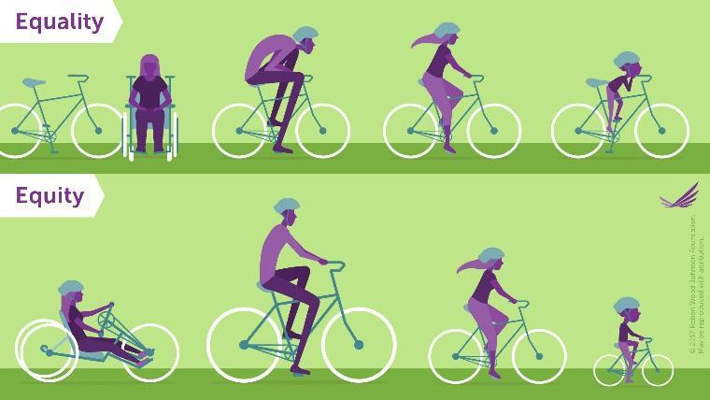
Figure 3. Visualizing Health Equity: One Size Does Not Fit All (RWJF)

- Culture of Health: The Robert Wood Johnson Foundation (RWJF) describes a Culture of Health as one in which well-being is placed at the center of every aspect of our lives. In a Culture of Health, Americans understand that we’re all in this together—no one is excluded. Everyone has access to the care they need and all families have the opportunity to make healthier choices. In a Culture of Health, communities flourish and individuals thrive. To help health care providers understand the principles of a Culture of Health, RWJF created a framework, which is structured around the concept of equity.

Section 3. Assessing Your Knowledge and Preparedness

Consistent with the five steps of the nursing process, we recommend Action Coalitions conduct a self-assessment to determine their readiness and needs for addressing SDOH. This process includes acknowledging and reflecting on existing work, efforts, and achievements through appreciative inquiry.

Assessment (SDOH and Health Equity): The Social Determinants of Health Assessment Survey has been adapted with permission from Janice Phillips, PhD, RN, FAAN, and Angelique Richard, PhD, RN, CENP, both of the Rush University Medical Center Department of Nursing Administration, to fit the needs of nurses and health care providers. The adapted survey, below, is used to assess nurses’ and interprofessional colleagues’ knowledge of and attitudes and behaviors toward addressing SDOH. It includes 10 questions and takes less than 10 minutes to complete. Results may help determine action steps to begin or support health equity work.

Social Determinants of Health Assessment Survey

Survey Purpose and Background
As a first step, we recommend that coalition members complete this survey. Identifying knowledge gaps can help coalitions address the education and informational needs of its members. CCNA has a library of resources, including webinars, blog posts, and references that provide in-depth information on the basic principles of SDOH and examples of efforts to address these at a community level.

Please respond to the following questions and feel free to add any additional information that can improve your efforts.

Questions About You and Your Practice (Demographics)
- Practice setting (select one):
  - Academic
  - Private practice
  - Ambulatory care/clinic
  - Hospital
  - Community health
  - Other (specify): ___________________________

- What is your current level of practice?
  - Nurse practitioner
    - PhD or DNP
    - Master’s prepared
    - Other (specify): ___________________________
  - RN
    - PhD or DNP
    - Master’s prepared
    - BSN
    - ADN
    - Diploma
  - LPN/LVN
  - CNA
  - Other health professional
  - Community partner

- How long have you been in your current role?
  - Less than 2 years
  - 2–4 years
  - 5–10 years
  - 11–15 years
  - 16–20 years
  - More than 20 years

- Have you received any specialized training to address social determinants of health?
  - Yes
  - No

If yes, who provided the specialized training?
- Employer
- School
- Informal, on-the-job training
- Conference/workshop
- Other (specify): ______________________

- Do you see patients in a clinical setting?
  - Yes
  - No (skip to question 7)

- If yes to question 5, in what setting?
  - Rural
  - Academic
  - Community
  - Urban
  - Other (specify): __________________________

Questions About Social Determinants of Health
- How knowledgeable are you about the following social determinants of health (social needs) in the lives of your patients or the community as a whole?

Social determinants of health | Not at all | Slightly | Moderate | Very | Extremely
Access to affordable, nutritious food
Access to care
Access to primary care provider
Civic participation (examples include: voting, community service, contacting elected officials, etc.)
Crime and violence
Discrimination
Employment status
Environmental conditions
Health literacy
Housing situation
Income
Interpersonal violence
Level of education
Social support networks
Transportation needs
Utilities

- How confident are you in your ability to discuss the following social determinants of health (social needs) with patients/community?

Social determinants of health | Not at all | Slightly | Moderate | Very | Extremely
Access to affordable nutritious food
Access to care
Access to primary care provider
Civic participation (examples include: voting, community service, contacting elected officials, etc.)
Crime and violence
Discrimination
Employment status
Environmental conditions
Health literacy
Housing situation
Income
Interpersonal violence
Level of education
Social support networks
Transportation needs
Utilities

- How likely are you to discuss the following social determinants of health (social needs) with patients/community?

Social determinants of health | Not at all | Slightly | Moderate | Very | Extremely
Access to affordable nutritious food
Access to care
Access to primary care provider
Civic participation (examples include: voting, community service, contacting elected officials, etc.)
Crime and violence
Discrimination
Employment status
Environmental conditions
Health literacy
Housing situation
Income
Interpersonal violence
Level of education
Social support networks
Transportation needs
Utilities

- What are the major barriers that prevent you from addressing social determinants of health with your patients or community?
  - Time
  - Resources
  - Lack of knowledge
  - Lack of referrals/community connections
  - Other___________________

Background: The article “Activating Nursing to Address Unmet Needs in the 21st Century” provides important background on the historical forces that shaped nursing; current developments that are repositioning nurses, including examples of nurse-involved models that have evidence of success; and nursing’s role in addressing the needs of the 21st century in partnership with the community. (See Section 6 below to learn more about planning for engaging potential partners.)

Section 4. Community Assessment

This phase includes gathering information about the community’s challenges and resources. Ideally, participants who identify priorities are community residents, health professionals, and other local leaders. The nursing role provides a unique position within the health care system to conduct a community assessment (in conjunction with the communities themselves) since nurses often have firsthand experience working on some of the most challenging and critical health needs locally, nationally, and globally.

A community assessment will also help show the assets or strengths and resources within a community that residents can build on for community improvement. Some communities or coalitions might already have an assessment for another purpose or project. The Community Health Assessment and Group Evaluation (CHANGE) Tool from the Centers for Disease Control and Prevention can guide members through the assessment and prioritization process.

Obtain input from as many sectors in the community as possible in identifying a community’s assets and strengths. Begin an inventory or list of all community assets. These may include organizations, people, places, associations, coalitions, and institutions. Other sources of information are the internet, community websites, the chamber of commerce, local newspapers, and county health departments.

These assets can then be mapped (see Section 5).

Environmental Scan

You can use the following tools to collect objective data related to community strengths and resources.

The Centers for Disease Control and Prevention (CDC) Social Vulnerability Index (SVI) uses U.S. census data to determine the social vulnerability of every census tract.
- A fact sheet about CDC’s SVI explains how it can help public health officials, including nurses, better prepare for and respond to emergency events (e.g., human suffering and financial loss in a disaster). These factors are known as social vulnerability and include poverty, lack of access to transportation, and crowded housing.
- Introduction to CDC's SVI (Video)
- Methods for CDC's SVI (Video)

County Health Rankings & Roadmap is an interactive website providing a snapshot of how health is influenced by where we live, work, and play, from the University of Wisconsin Population Health Institute.
City Health Dashboard is a searchable database of U.S. cities providing 37 measures of health and drivers of health equity, from the National Resource Network, the Department of Population Health at NYU Langone Health, and the Robert F. Wagner School of Public Service at NYU.
AARP Livability Index is a web-based tool (using address, ZIP code, or community) to measure community livability by categories related to housing, neighborhood, transportation, environment, health, engagement, and opportunity.

Section 5. Social Diagnosis: Deciding Priority Social Determinants of Health to Take Action On

In primary care and clinical settings, there are growing efforts to link SDOH to the International Statistical Classification of Diseases and Related Health Problems, Tenth Revision (ICD-10) diagnoses. This coding guideline allows the clinical care team, including care managers, community health workers, medical assistants, nurses, discharge planners, behavioral health clinicians, and dental staff members to document a “social diagnosis” in the electronic health record in the form of “Z-codes” (examples: Z59.9 is “problem related to housing and economic circumstances, unspecified”; Z60.4 is “social isolation, exclusion and rejection”).

In a community setting, once you conduct an assessment, Action Coalitions (or any coalition using the tool) can work with partners and stakeholders to define and prioritize the SDOHs to address. One simple recommendation made by the Community Tool Box for Identifying Community Assets and Resources (see the Resource Hub) is to list all of the SDOH your community is facing and form criteria that can help decide action. For example, here are some questions that may help with decision-making:

- Is the SDOH of importance to the Action Coalition, including partners and stakeholders?
  - Define the most important SDOH that must be addressed now, in the short term, based on collective decision-making.
  - Define the important SDOH that can be addressed long term.
- Given the current capacity of the Action Coalition, is it feasible to address the SDOH?
- Will this effort, with your limited resources, produce the most impact for the most people in your community?
- If you succeed in bringing about the solution you are working on, what are the possible consequences? Even if there are some unwanted results, you may well decide that the benefits outweigh the negatives.

Section 6. Planning

What Is Community Engagement?

Community problems are often too complex for any one agency to address, making community engagement an essential step for developing community-based solutions and advancing health equity. Community engagement is a process that engages community members, organizations, institutions, and other relevant stakeholders to pursue solutions or interventions that address the issue at hand. Central to this process is recognizing that community residents are the most important resource in the community. Relationship-building with community members takes time and involves certain strategies. See the CDC’s A Practitioner’s Guide for Advancing Health Equity for strategies on community engagement.

Here is how to build your coalition or community team:

Identify Partners, Stakeholders, and Potential Funders

Maintain a list of individuals and groups that are essential to include. (See Figure 4.)

Professional nursing organizations representing diversity in the workforce are well prepared to work in partnership with others to advance health equity in their community. The members of CCNA’s Equity, Diversity, and Inclusion Steering Committee highlight health equity as central to their mission and encourage outreach to their local and state chapters. Each includes contact/outreach information on their websites:

- American Association for Men in Nursing
- Asian American/Pacific Islander Nurses Association, Inc.
- National Alaska Native American Indian Nurses Association
- National Association of Hispanic Nurses
- National Black Nurses Association, Inc.
- National Coalition of Ethnic Minority Nurse Associations
- Philippine Nurses Association of America, Inc.

Essential partners to include are community members most affected by the issue or concern and community organizations whose duties relate to the issue. Begin thinking about key individuals and organizations who have a vested interest in your efforts. Representation should be diverse and broad.

Other partners may include state, tribal, county, and local governments, educational institutions, and health care institutions.

One helpful resource when considering partners is from Healthy People 2020: Brainstorm potential partners.

Organize and Mobilize Partners

As you consider forming your coalition, you will need to consider partners’ roles and how you will work with them to coordinate efforts. Below are some useful resources to help in the planning of your mobilization efforts.

Healthy People 2020: Questions to consider when organizing a coalition https://www.healthypeople.gov/sites/default/files/QuestionsToConsider.pdf

Healthy People 2010: https://www.healthypeople.gov/2020/tools-and-resources/program-planning/Mobilize

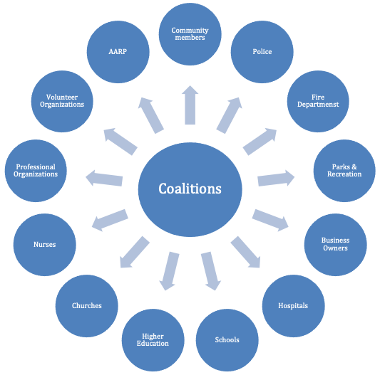

Figure 4: Examples of potential coalition membership (adapted from Community Wellness Planning Kit).

Below are the initial steps to take as you consider potential coalition participants.

    - Assemble a core team that has the responsibility for the coalition’s efforts.
    - Create a communication plan to map out your communication efforts and help to develop a clear message and identify your target audience. To develop your communication plan, answer the following questions:
      - Why do you want to communicate your information? (Purpose.)
      - Who is your target audience?
      - What do you want to communicate to your audience?
      - How do you want to communicate your information?
      - What resources are available to help communicate your message?

Table 2: Example of a Communication Action Plan
Audience | Content | Communication  Format/Media | Resources | Timing of Communication
Source: The Pell Institute (2019).

For guidance on communication plans, consider these sample pieces.

    - Louisiana Action Coalition’s infographic “The Diversity of Louisiana’s Registered Nurses Workforce.”
    - Wisconsin Action Coalition’s infographic “Diversity in Nursing: A Solution for Wisconsin.”
    - The National Association of Hispanic Nurses’ “Communicating With the Media: NAHN Educating Multicultural Communities on Health Insurance Literacy,” below (A. Perez).

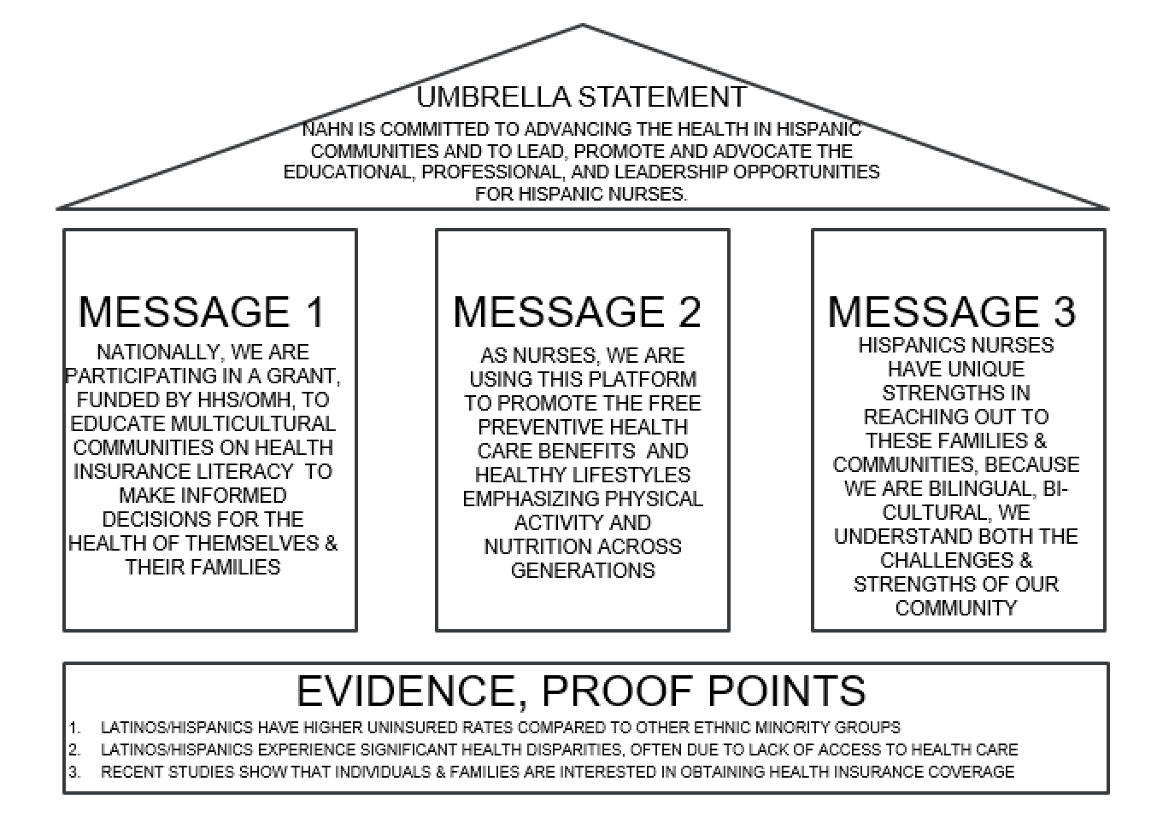

Above: Sample communication outline for “Communicating With the Media: NAHN Educating Multicultural Communities on Health Insurance Literacy”

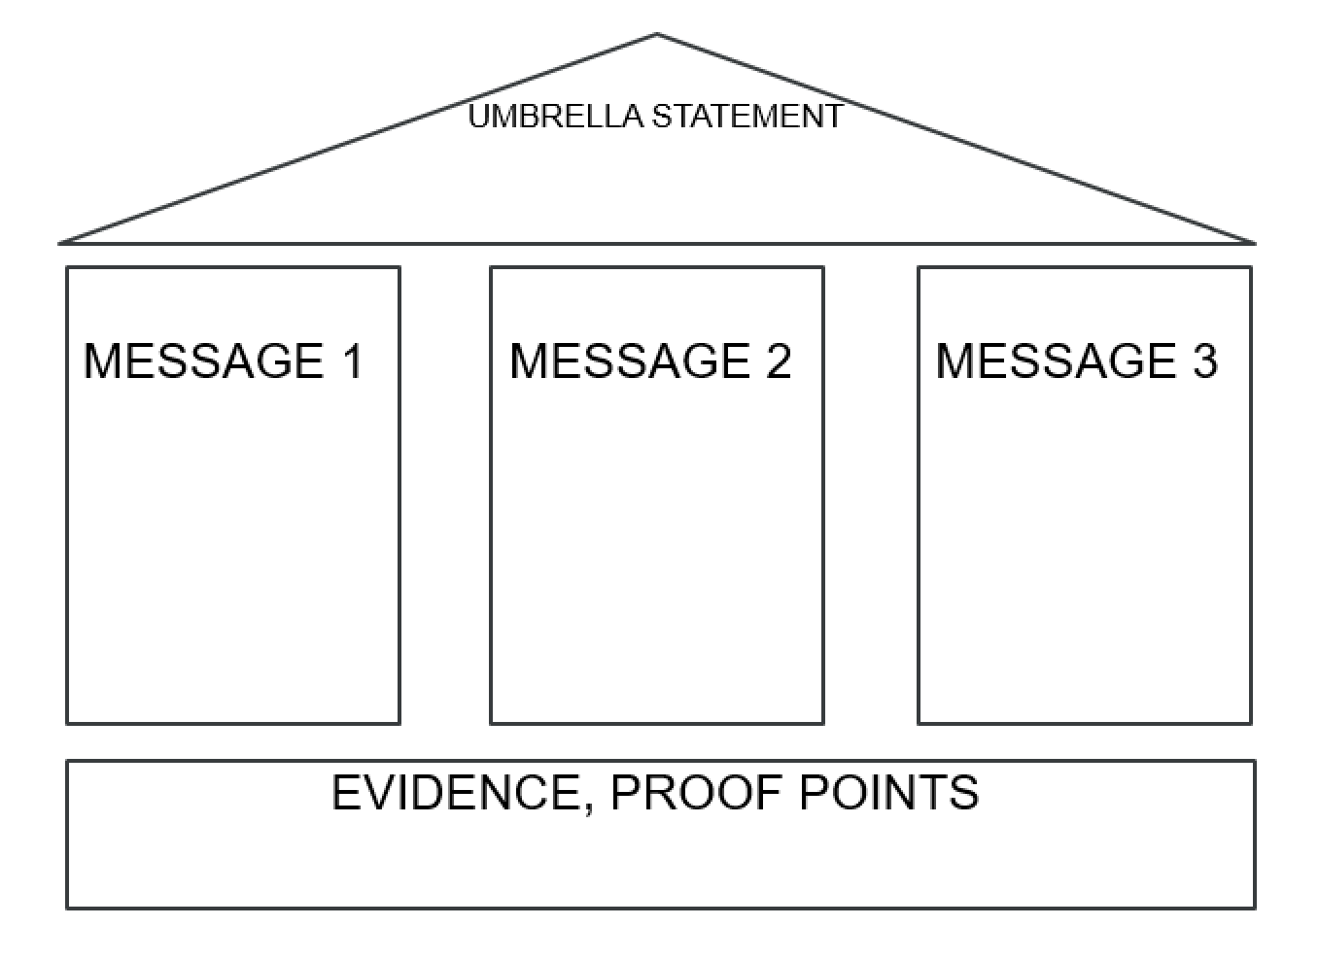

Above: Template for crafting your communication with media (D. Mason)

Establish a Strategic Plan

List SMART (specific, measurable, actionable, relevant, time-limited) goals that will support the coalition’s efforts.

Table 3: SMART Goals
Goal 1
Goal 2
Goal 3

Outreach to Partners

Now that you have identified members to be in your coalition and community needs, and established a clear objective, it is time to identify the pathway to contact team members. List the names and contacts for partners in the effort.

Table 4: Team Members and Contact Information
Team Member Name | Contact Information

Stakeholders/Supporters and Potential Funders

List the people and/or organizations who could be strong supporters and potential funders in actualizing the goals. In this area think broadly about potential advocates and ambassadors.

For each stakeholder, write a sentence or two about why they should be interested in investing time and resources into this issue. (These sentences can serve as the opener for the initial conversation.)

List the steps you will take to gain visibility and interest from stakeholders/supporters and potential funders and the broader community.

Table 5: Stakeholder List

 | Name | Contact Information | Who will contact them | Date by which the stakeholder will be contacted
Stakeholder/Supporter and Potential Funder
Write a statement about how the coalition’s goals and efforts will align with or benefit the stakeholder.
What are stakeholder/supporter and/or potential funder priorities?

How can the coalition support them?

How can nurses add value to the stakeholder priorities?
Is there a mechanism to recognize or reward stakeholders/supporter and/or potential who have provided support?

Fundraising

CCNA has provided templates, guidance, and more for Action Coalitions seeking financial stability and long-lasting relationships with funding supporters. These resources include:

Fundraising to support diversity work, an article from Campbell & Company, directed at Action Coalitions, with ideas about developing a philanthropic relationship with donors.

Fundraising Toolkit Materials, which includes the following information and support materials:
- Core Pillars of Successful Fundraising: This overview presents descriptions of the four areas that comprise a best-practice fundraising program—donor engagement, leadership, case for support and internal operations. The overview also includes key questions for Action Coalitions to consider as they build or strengthen their work in each of these areas.
  - Fundraising Principles: This overview includes descriptions of three fundamental fundraising concepts that lead to efficient, effective, donor-centered fundraising operations—the donor pyramid, relationship management and return on investment in fundraising.
  - Case for Support Materials: This workbook describes the case development process, from initial conversations through to the creation of donor-ready collateral materials. It includes a series of worksheets and exercises the advance Action Coalitions through the process.
  - Special Event Planning Guide: This workbook includes a planning tool for developing and preparing for a fundraising event, with a series of questions and exercises for Action Coalitions. It also includes pre- and post-event evaluation tools and benchmarks.
  - Prospect Research Source Guide: This resource guide includes details on the goals of prospect research and a comprehensive list of resources for conducting research online. It also includes research profile templates.
  - Sample Donor Funder Messages and Sample Case Presentation: These two pieces build off of the case workbook provided in the previous set of materials, providing a suggested framework for talking about your Action Coalition with a potential donor or funder. The documents include suggestions on how to tailor the text based on your work and goals as well as based on your audience.
  - Building Widespread Support and Engagement : This document considers different structures that various Action Coalitions have used to build engagement and interest in their states, including models for membership as well as suggestions on types of fundraising appeals.
  - Volunteer Engagement Toolkit: This toolkit provides a set of resources for engaging volunteers in supporting fundraising efforts and includes opportunities for different levels of involvement based on individuals’ comfort level and interest in helping with fundraising.
  - Relationship Management Toolkit and Relationship Mapping Worksheet: This toolkit gives an overview of the typical cycle that a potential donor or funder goes through before and after making a gift. It includes resources for each step in that cycle. The supplemental Relationship Mapping Worksheet is a template you can use with volunteers to ask them to help identify connections they might have to potential funders or donors. An additional Prospect Tracking Spreadsheet is in development and will be added to the resource center when finalized.
  - Fundraising Operating Plan Template: This template lays out the key elements that make up a strong annual fundraising plan, including overarching goals, a budget, calendar and key implementation steps. Many of the other materials that have been developed through the fundraising program can “feed into” the fundraising operating plan.

Section 7. Action/Implementation

Following are examples from nurses in the field implementing processes and practices that pave the way to greater health equity.

Humana’s Bold Goal Communities: This website highlights community-specific efforts from across the country designed to improve health. They address issues like integrative care, obesity, diabetes, disaster preparedness, and more. Written materials and brief videos provide examples of the kinds of efforts communities are implementing to uplift health. For example, in Atlanta, residents in the metro-Atlanta area receive close to 5,000 healthy meals thanks to a partnership with Open Hand Atlanta. In Jacksonville, the community acknowledged that it had some of the poorest health outcomes in the country, and has begun a program to become 20% healthier by 2020.

Future of Nursing: Campaign for Action’s Innovations Fund: Twenty-one states have been awarded grants through the Nursing Innovations Fund to lead groundbreaking work to build a Culture of Health, which includes engaging a diversity of stakeholders. These resources can help identify new partners to bring into your work, build on promising practices, and spark ideas among your network.

NowPow Platform: This platform provides personalized community referral solutions, making it easy to connect people and organizations to the right resources to help the communities they serve.

Pennsylvania Action Coalition: The "At the Core of Care” podcast highlights the consumer experience of patients, families, and communities and the creative efforts of nurses and other partners to better meet their health and health care needs through diversity, leadership, and practice innovation.

“Nurses Change Lives”: This Johnson & Johnson video highlights the evolution of the nursing workforce’s practices to effect change and improve care for their communities.

“The Art of Practicing Health Care”: This video highlights the important role nurse practitioners are playing in delivering primary care in rural West Virginia.

Section 8. Evaluating Impact

Recognition: What has changed in the issues of the community you hoped to address?

- What policy suggestions could you make as a result of your effort?
  - Professional/clinical guideline change (e.g., insurance coverage determination for SDOH)
  - Organizational (e.g., hospital system change, worksite policy)
  - Local/state (e.g., complete streets/zoning change, state regulation change, Food assistance, state legislation, state level funding)
  - National/federal (e.g., health insurance coverage, Medicaid/Medicare, regulatory or administrative action, executive order)
- What health outcome/s or health behaviors have changed as a result of your work?
  - Increase in physical activity rates in the community
  - Increase in vaccination rates
  - Increase in SNAP assistance, enrollment, renewal

Replication: Could your strategy be replicated by another community? If so, how?

What are state/local adaptations that can be made that you have discovered as a result of your work (e.g., has this work been adapted by others)?

Additional references for guidance on evaluation.

“Evaluating Strategies For Reducing Health Disparities By Addressing The Social Determinants Of Health,” a 2016 article in Health Affairs, reviews evidence from “promising interventions” that focus on SDOH targeting education and early childhood; urban planning and community development; housing; and economic stability. These examples may help guide an evaluation on health outcomes, cost-effectiveness, and long-term sustainability for implementation at local, state, and national levels.

Section 9. Resource Hub

Explore guides, links, and tools to inform your action plan.

Built Environment
AARP Walk Audit Tool Kit. A step-by-step service guide for assessing a community’s walkability

Communication and Messaging
- Health Equity in Public Policy: Messaging Guide for Policy Advocates
- Crucial Conversations: Tools for Talking When Stakes Are High by Kerry Patterson, Joseph Grenny, Ron McMillan, and Al Switzler
- Louisiana Action Coalition’s infographic “The Diversity of Louisiana’s Registered Nurses Workforce”
- Wisconsin Action Coalition’s infographic “Diversity in Nursing: A Solution for Wisconsin”
- The National Association of Hispanic Nurses’ “Communicating With the Media: NAHN Educating Multicultural Communities on Health Insurance Literacy,” (see Section 6).

Food Insecurity
- Feeding America: Working together to end hunger
- Feeding America: Taking Action to help hardworking families
- Food Research & Action Center—a national nonprofit organization working to eliminate poverty-related hunger and undernutrition in the U.S.

Fundraising
- Campaign for Action: Fundraising to support diversity work
- Campaign for Action: Fundraising Toolkit Materials
    - Core Pillars of Successful Fundraising
    - Fundraising Principles
    - Case for Support Materials
    - Special Event Planning Guide
    - Prospect Research Source Guide
    - Sample Donor Funder Messages
    - Sample Case Presentation
    - Building Widespread Support and Engagement
    - Volunteer Engagement Toolkit
    - Relationship Management Toolkit
    - Relationship Mapping Worksheet
    - Fundraising Operating Plan Template

Health Disparities
- National Partnership for Action to End Health Disparities: Toolkit for Community Action
- Humana’s Bold Goal Communities
- Community Health Training Institute’s Health Equity Toolkit
- Rural Health Information Hub: Social Determinants of Health for Rural people
- The CDC Community Health Assessment and Group Evaluation (CHANGE) Data-collection Tool and Planning Resource
- The Guide to Community Preventive Services (The Community Guide) is a collection of evidence-based findings of the Community Preventive Services Task Force
- Center for Community Health and Development at the University of Kansas Community Tool Box for Identifying Community Assets and Resources
- The CDC: A Practitioner’s Guide for Advancing Health Equity

Health Equity Training Modules and Resources
- Prevention Institute: Health Equity Training Series
- Addressing Health Equity: A Public Health Essential (course with continuing education credits)

Indicators for Health, SDOH, and Health Equity
- RWJF County Health Rankings
- This website is a comprehensive resource for those who want to know about health issues in their communities and/or for those who seek information about how to move from conversations about improving health to action. The “Explore Health Rankings” section is a tool for assessing health factors, health outcomes and health rankings for counties across the United States. All you need to do to get started is enter the state or county of interest. The “Take Action to Improve Health” section provides examples of evidence-informed policies and programs, step-by-step guidance and actionable tools, and information about potential partners and how to engage them. The “Learn From Others” section includes webinars and features written stories of communities in action to improve health in their communities.
- CDC’s Social Vulnerability Index (SVI)
- Introduction to CDC's SVI (Video)
- Methods for CDC's SVI (Video)
- City Health Dashboard
- AARP Livability Index

Leadership Training and Fellowships
- Atlantic Fellows Programs
- Health and Aging Policy Fellows Program
- RWJF Culture of Health Leaders
- Fellowship in Health Policy and Media
- Betty Irene Moore Fellowships for Nurse Leaders and Innovators

Native Americans
- Healthy People 2020
- National Congress of American Indians
- National Indian Council on Aging resource links for elders/older population
- Tribal Equity Toolkit

Nursing Organizations
- American Academy of Nursing
- American Association for Men in Nursing
- American Association of Critical-Care Nurses
- Asian American/Pacific Islander Nurses Association, Inc.
- American Nurses Association
- National Alaska Native American Indian Nurses Association
- National Association of Hispanic Nurses
- National Black Nurses Association, Inc.
- National Coalition of Ethnic Minority Nurse Associations
- National League for Nursing
- Philippine Nurses Association of America, Inc.

Obesity
CDC Health Equity Resource Toolkit for State Practitioners Addressing Obesity Disparities

Policy
- Policy resources to support SDOH
- The Community Guide: Develop Evidence-Based Policies

Social Determinants and Health Impact
- Healthy People 2020–Housing Insecurity
- Healthy People 2020–Food Insecurity
- Healthy People 2020–Employment
- Healthy People 2020–Education
- Healthy People 2020–Access to Health Services
- Healthy People 2020–Environmental Conditions
- Healthy People 2020–Crime and Violence
- Healthy People 2020-Incarceration

Understanding Racism
- Jones, C. P. (2000). Levels of racism: A theoretic framework and a gardener’s tale. American Journal of Public Health, 90, 1212-1215.
- Jones, C. (2014). Systems of power, axes of inequity: parallels, intersections, braiding the strands. Medical Care, 52(12). S71-S75.
- Ford, C.L., Griffith, D.M., Bruce, M.A., Gilbert, K.L. (2019). Racism: Science & tools for the public health professional. Washington, DC: APHA Press.
- Raceforward.org
- Compton, M.T., and Shim, R.S. (2015). The social determinants of mental health. Arlington, VA: American Psychiatric Publishing.
- Brockie, T.N., Heinzelmann, M., & Gill, J. (2010). A framework to examine the role of epigenetics in health disparities among Native Americans. Nursing Research and Practice (2013), 1-9.
- Human Genome Project. Retrieved from https://www.genome.gov/human-genome-project
- Roberts, D. (2008). Is Race-Based Medicine Good for Us? African American Approaches to Race, Biomedicine, and Equality. The Journal of Law, Medicine & Ethics, 36(3), 537-545.
- Moscou, S., Baker, S.(2019) The role of race in clinical decision making. Nurse Practitioner, 43(3), 41-46.
- Yudell, M., Roberts, D., DeSalle, R., Tishkoff, S. (2016) Taking race out of human genetics: Engaging a century-long debate about the role of race in science. Science, 6273, 564-565.

Section 10. About the Authors

Kupiri “Piri” Ackerman-Barger, PhD, RN, FAAN, is associate dean of Health Equity, Diversity and Inclusion as well as an associate clinical professor at the University of California Davis Betty Irene Moore School of Nursing. She serves as a researcher for the Center for a Diverse Healthcare Workforce working to diversify the health professions’ pipeline. Ackerman-Barger is also a diversity adviser for the Future of Nursing: Campaign for Action. She earned a doctor of philosophy in nursing education from the University of Northern Colorado, a master of science in nursing education from California State University, Sacramento, and a bachelor’s degree in nursing from Humboldt State University.

Jazmine Cooper, MBA, is a project manager for CCNA, an initiative of AARP Foundation, AARP, and the Robert Wood Johnson Foundation to improve America’s health through nursing. Cooper coordinates several projects of the Future of Nursing: Campaign for Action, a national effort of those same three organizations to transform health care through nursing and build healthier communities for everyone in America. Her work supports the Campaign’s Strategic Advisory Committee, Equity, Diversity, and Inclusion Steering Committee, Champion Nursing Coalition, and Champion Nursing Council. Cooper is the lead project manager for the Campaign’s mentor-training workshops and learning collaboratives for minority-serving schools of nursing and the state-based Action Coalitions. She serves as the liaison to multiple national minority nursing organizations and federal organizations. She also provides technical assistance to Action Coalitions on their fundraising, and coordinates speaking engagements that promote the Campaign. Cooper obtained her bachelor’s degree in psychology from Bowie State University and her master’s in business administration from the University of Maryland University College.

Regina Eddie, PhD, RN, is an assistant professor at the Northern Arizona University School of Nursing. She is a Robert Wood Johnson Foundation Nursing and Health Policy Collaborative fellow and a diversity adviser for the Future of Nursing: Campaign for Action. Her program of research is focused on using socio-ecological and Navajo cultural frameworks to evaluate school food policies and practices. Eddie’s dissertation study highlighted the importance of policy and school engagement for promoting health in children and assisting in prevention of childhood obesity in the Navajo Nation. As an enrolled member of the Navajo (Dine’) Nation, and thus rooted in culture and tradition, and with her experience as a public health nurse and program director serving Navajo communities, Eddie possesses an in-depth knowledge and understanding of the many health issues and disparities affecting underserved populations in reservation communities. Eddie received her PhD in nursing from the University of New Mexico and her bachelor’s and master’s degrees from Northern Arizona University.

Claudio W. Gualtieri, JD, is undersecretary for Health and Human Services Policy and Planning Division for the state of Connecticut. He previously served as a senior adviser for CCNA, an initiative of AARP Foundation, AARP, and the Robert Wood Johnson Foundation. He was responsible for stakeholder engagement and advocacy for the Future of Nursing: Campaign for Action, a national initiative of those same organizations to transform health care through nursing and build healthier communities for everyone in America. Gualtieri supported Campaign outreach to AARP state offices, the Campaign’s state-based Action Coalitions and community partners. Before joining CCNA, Gualtieri worked for over 12 years at AARP Connecticut, where he planned and executed legislative strategy on health care, long-term support services, and family caregiving. He also led consumer outreach initiatives to help family caregivers find and use local resources and assistance. Gualtieri earned his bachelor’s degree at Cornell University and a juris doctorate at the UConn School of Law. He is admitted to practice law in Connecticut.

Lisa Martin, PhD, RN, FAAN, is an enrolled member of the Lac Du Flambeau Band of Lake Superior Chippewa Indians, is an associate professor of nursing at St. Catherine University, St. Paul, Minn., with extensive experience teaching in graduate and undergraduate nursing programs. She has worked as a public health nurse with economically disadvantaged families and as a clinical educator, nursing supervisor, and project manager with several interdisciplinary public health programs. Martin serves on the board of directors of the Indian Health Board of Minneapolis, Inc., and is immediate past president of the National Alaska Native American Indian Nurses Association. She is a diversity adviser to the Future of Nursing: Campaign for Action. Her areas of interest include American Indian health care and research, diabetes prevention in American Indian youth, nursing education, holistic nursing, cultural competency, and inclusivity.

Barbara Nichols, MS, RN, FAAN, is the executive director of the Wisconsin Center for Nursing and a diversity adviser for the Future of Nursing: Campaign for Action. She provides expert consultation on global nursing execution, practice, and leadership. She served for 12 years as chief executive officer of CGFNS International, an immigration-neutral organization whose expertise regarding the education, registration, and practice of foreign-educated nurses and other health professionals is recognized worldwide. Nichols has held a state cabinet position dealing with statutory regulation of 59 occupations and is a former president of the American Nurses Association. She is the recipient of five honorary doctoral degrees and of numerous awards for her leadership and sustained contributions to the nursing profession. Nichols holds a diploma in nursing from Massachusetts Memorial Hospital, in Boston; a bachelor’s in nursing from Case Western Reserve; and a master’s from the University of Wisconsin.

G. Adriana Perez, PhD, CRNP, FAAN, is an assistant professor of nursing and senior fellow at the Leonard Davis Institute of Health Economics at the University of Pennsylvania School of Nursing. As a current scientist at Penn’s Center for Improving Care Delivery for the Aging, she conducts research focused on the influence of community-level factors and resource utilization on sleep and well-being of home-dwelling, multiethnic older adults with Alzheimer’s disease and related dementias and their caregivers. Perez also serves as a board-certified adult nurse practitioner at Mercy LIFE, a community-based long-term care for frail elders who reside in North Philadelphia, and as a diversity adviser for the Future of Nursing: Campaign for Action. She received her PhD, master’s, and bachelor’s degrees in nursing from Arizona State University, College of Nursing & Health Innovation.

References
Andermann, A. (2016). Taking action on the social determinants of health in clinical practice: a framework for health professionals. CMAJ, 188(17-18), E474-E483.
Braveman, P., Arkin, E., Orleans, T., Proctor, D., Plough, A. (2017). What is health equity? Robert Wood Johnson Foundation. Retrieved from https://www.rwjf.org/en/library/research/2017/05/what-is-health-equity-.html
Brockie, T.N., Heinzelmann, M., & Gill, J. (2010). A framework to examine the role of epigenetics in health disparities among Native Americans. Nursing Research and Practice (2013), 1-9.
Castrucci, B.C. & Auerbach, J. (2019). Meeting individual social needs falls short of addressing social determinants of health. Health Affairs. DOI: 10.1377/hblog20190115.234942. Retrieved from https://www.healthaffairs.org/do/10.1377/hblog20190115.234942/full/
Compton, M.T., and Shim, R.S. (2015). The Social Determinants of Mental Health. Arlington, VA: American Psychiatric Publishing.
Felitti, V.J., Anda, R.F., Nordenberg, D., Williamson, D.F., Spitz, A.M., Edwards, V... Marks, J. (1998). Relationship of Childhood abuse and household dysfunction to many of the leading causes of death in adults: The adverse childhood experiences (ACE) study. American Journal of Preventative Medicine, 14, 245-248.
Friedman, N. L., & Banegas, M. P. (2018). Toward addressing social determinants of health: A health care system strategy. The Permanente Journal, 22.
Hassmiller, S. (2019). Perfectly positioned: galvanizing nurses to address the social determinants of health. Health Affairs. Retrieved from https://www.healthaffairs.org/do/10.1377/hblog20190429.781982/full/
Health People 2020. Retrieved from https://www.healthypeople.gov/2020/
Holt-Lunstad J, Smith TB, Layton JB (2010) Social Relationships and Mortality Risk: A Meta-analytic Review. PLoS Med 7(7
Human Genome Project. Retrieved from https://www.genome.gov/human-genome-project
Jones, C. (2014). Systems of power, axes of inequity: parallels, intersections, braiding the strands. Medical Care, 52(12). S71-S75.
Manchanda, R. (2014). What makes us get sick? Look upstream. [Video] TedTalks. Retrieved from https://www.ted.com/talks/rishi_manchanda_what_makes_us_get_sick_look_upstream?language=en
Metzel, J.M. & Hansen, H. (2014). Structural competence: Theorizing a new medical engagement with stigma and inequality. Social Science & Medicine, 103, 126-133.
Olson, D. P., Oldfield, B. J., & Morales Navarro, S. (2019). Standardizing social determinants of health assessments. Health Affairs Blog. https://www.healthaffairs.org/do/10.1377/hblog20190311.823116/full/.
Schaffer, M. & Strohschein, S. (2019). Public health interventions: Applications for public health nursing practice. (2nd ed.). Minnesota Department of Public Health. Retrieved from https://www.health.state.mn.us/communities/practice/research/phncouncil/docs/PHInterventions.pdf
Seeman, T., Singer, B., Rowe, J., McEwen, B. (1997) Price of adaptation- allostatic load and its health conequences. Archives of Internal Medicine, 2259-2268.
Thornton, R. L., Glover, C. M., Cené, C. W., Glik, D. C., Henderson, J. A., & Williams, D. R. (2016). Evaluating strategies for reducing health disparities by addressing the social determinants of health. Health Affairs, 35(8), 1416-1423. Retrieved from https://www.ncbi.nlm.nih.gov/pmc/articles/PMC5524193/.
Williams, D. R. (2020). Why Discrimination Is a Health Issue. RWJF. Retrieved from https://www.rwjf.org/en/blog/2017/10/discrimination-is-a-health-issue.html.
Wilson, C. & Moulton, B. (2010). Loneliness among Older adults: A national survey of 45+. Prepared by Knowledge Networks and Insight Policy Networks. Washington DC: AARP. Retrieved from https://assets.aarp.org/rgcenter/general/loneliness_2010.pdf.
Yudell, M., Roberts, D., DeSalle, R., Tishkoff, S. (2016) Taking race out of human genetics: Engaging a century-long debate about the role of race in science. Science, 6273, 564-565.

