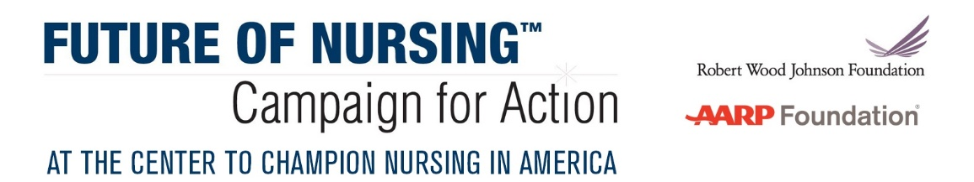
The Innovations Fund

DESCRIPTION
The Future of Nursing: Campaign for Action, a joint initiative of the AARP Foundation, AARP, and the Robert Wood Johnson Foundation (RWJF), will provide $25,000 each to 10 Action Coalitions that demonstrate a commitment to sustainability by advancing at least one recommendation from the Institute of Medicine (IOM) report—The Future of Nursing: Leading Change, Advancing Health, while connecting their work to RWJF’s Culture of Health framework. The goal of this two-year competitive funding opportunity is to create replicable strategies that sustain Action Coalition work while highlighting the importance of collaboration with diverse stakeholders.

A 1:1 match is required for each dollar given to the Action Coalition. Therefore, applicants must have at least $25,000 in matching funds to be eligible to apply. In-kind donations are welcomed and valued, but will not count towards the $25,000 cash match.

In the past, RWJF awarded grants to many Action Coalitions through the Future of Nursing: State Implementation Program (SIP). A key part of that program was developing and implementing sustainability plans. While SIP has ended, the Campaign for Action encourages Action Coalitions to remain committed to strengthening stakeholder engagement and diversity.

The Culture of Health framework emphasizes the importance of cross-sector collaboration and building effective relationships. Working together with outside community partners will strengthen sustainability efforts while leading to greater impact. Here are a few ways that Action Coalitions might enhance their work as they build stronger coalitions:
- Collaborate with diverse partners with similar goals (i.e. local health departments, schools, businesses for workplace health promotion)
- Join forces with other effective campaigns
- Look for alternative funding sources through corporate giving, state or federal grants, or individuals
- Work with non-nursing partners to promote mutually beneficial policies that will lead to greater improvements in health and well-being

Some of these examples and additional information are outlined on RWJF’s Culture of Health website, including ways to measure successful cross-sector collaboration. Please use this resource as you are developing your sustainability strategies.

ELIGIBILITY CRITERIA
Action Coalitions committed to creating innovative, replicable sustainability plans that incorporate diversity and increase cross-sector stakeholder engagement are encouraged to apply for the Innovation Fund. Applicant organizations must:
- Earn 1:1 matching funds for a minimum of $25,000
- Advance and enhance the work of at least one IOM recommendation while connecting the work to the Culture of Health framework
- Show evidence of replicability
- Show evidence of sustainability
- Show evidence of multi-sector partnerships
- Include a diversity action plan as part of the overall plan in an appendix
- Be a tax-exempt organization under Section 501(c)(3) of the Internal Revenue Service Code

USE OF FUNDS
Funds may be used for staffing, meetings, supplies, project-related travel, and consultants. Funds may not be used to subsidize individuals for the costs of their health care, to support clinical trials of unapproved drugs or devices, to construct or renovate facilities, for lobbying, for political activities, or as a substitute for funds currently being used to support similar activities. Chosen applicants will be required to report on the use of their Innovation Funds at the end of 2018 and at the end of the funding period in late 2019.

DIVERSITY STATEMENT
All projects should strive to increase diversity of the nursing student, faculty, and workforce. This objective can be obtained by recruiting diverse stakeholders and partners, which in turn, better positions nurses as community leaders.

Consistent with RWJF values, this program embraces diversity and inclusion across multiple dimensions, such as race, ethnicity, gender, age and disadvantaged socioeconomic status. We strongly encourage applications that will help us expand the perspectives and experiences we bring to our work. We believe that the more we include diverse perspectives and experiences in
our work, the more successful we will be as we strive together to build a Culture of Health, enabling all in our diverse society to lead healthy lives, now, and for generations to come.

HOW TO APPLY
Proposals should be submitted via email to Innovationsfund@AARP.org and will handled by the Center to Champion Nursing in America (CCNA), an initiative of AARP Foundation, AARP and RWJF. The program will be staffed by Winifred Quinn, PhD, CCNA’s director of advocacy and consumer affairs, and Christine Borkoski, CCNA project manager.

Application questions are listed below. In fairness to all applicants, the program will not accept late submissions. All funding decisions will be made by a review team consisting of Campaign for Action leadership staff and external advisors.

PROGRAM SUPPORT
CCNA will provide direction and technical assistance for those who receive innovation funding. In fact, all applicants, regardless of whether they secure an innovation award, will be given technical assistance throughout the year and opportunities to work with a consultant designated by the Campaign.

Questions? Please send them to Innovationsfund@aarp.org.

KEY DATES AND DEADLINES in 2018
February 23, 1- 2 p.m. ET | Webinar for interested applicants
April 6, 10 p.m. ET | Application deadline
May | Finalists notified of funding recommendations
June 1 | Project initiated
May 2 through December 31 | Technical assistance provided

APPLICATION QUESTIONS
Please answer all questions.
Page limit: 10 pages

Applicant Name:
Applicant Organization:

- Describe your work advancing at least one IOM pillar and how you are incorporating the Culture of Health framework?
- How will you replicate and/or expand the scale of the project?
- How will your project advance leadership in nursing?
- Describe the involvement of partners. If new partners are needed, describe how those partners will be engaged in the work.
- How will you accomplish the work? Do you have the time to commit and/or staff that can commit to carrying out the work?
- Are matching funds available? Where will the match come from?
- How will you disseminate the results of your project? Who are the key audiences for dissemination?
- What is your budget for the project, including all in-kind donations? Please include a brief budget narrative.
- What is your timeline for the project?
- How does your diversity plan relate to your Culture of Health work?

