Nurses Week 2016
Guide for Action Coalitions

Introduction
This year the Future of Nursing: Campaign for Action is excited to celebrate Nurses Week, May 6–12!

To get started, please visit these pages to learn what we have planned for Nurses Week 2016 and how you and your Action Coalition and supporters can get involved:
- Celebrate National Nurses Week 2016
Social Media Campaign
The Campaign will be running a dynamic social media campaign during Nurses Week and we want you involved! We’ll be sharing a series of photos and stories throughout Nurses Week sure to inspire your Action Coalition’s supporters.

Be sure to follow us on Twitter and “like” us on Facebook to re-share and re-tweet this content to your fans and followers, and remember to use the #NursesWeek and #FutureofNursing hashtags!
Are We Friends?
We want to support your work and engage with you online, so if the Campaign’s not a “fan” of your Action Coalition’s Facebook page or following you on Twitter, please let us know.
Photos
Below are two photos with draft posts your Action Coalition may use to celebrate Nurses Week. We suggest that you that you tailor the suggested posts below to meet your state’s goals and include a call to action in your post to visit your state’s website or state Action Coalition landing page.
While the images look identical, please note that they are slightly different because each version is sized optimally to display on Facebook and Twitter. You can save each image to your computer by right-clicking them and saving the photo. If you need high-resolution versions of these images, please request them by e-mailing Meredith Courville.

For Facebook:
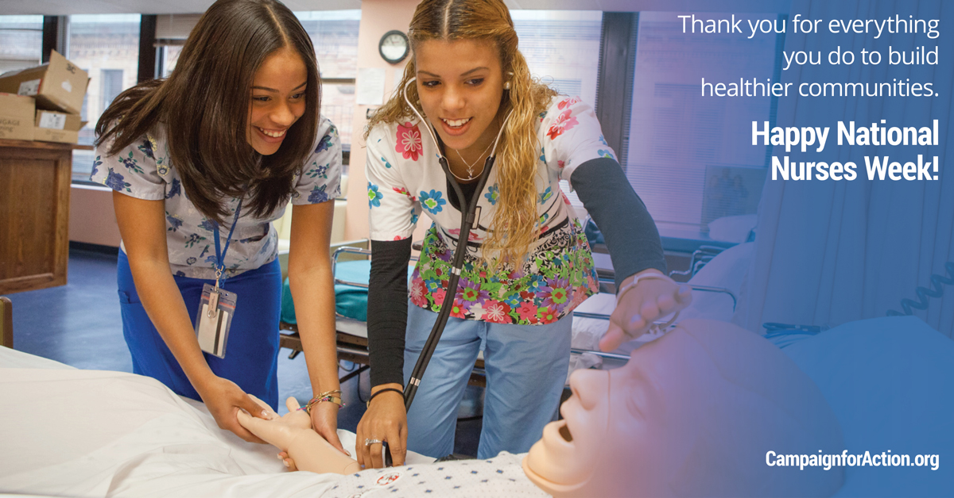
Draft Facebook post: Learn more about how the [insert name of your state] Action Coalition is working to improve health through nursing in the [insert nickname of state] State! [insert link to your website.]
For Twitter:
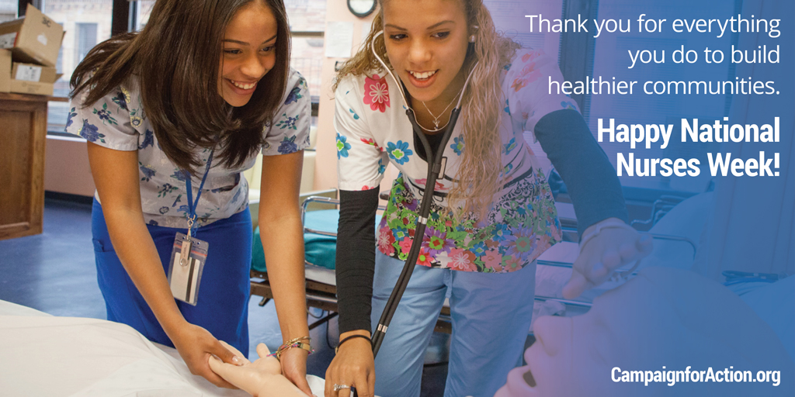
Draft Tweet: Learn how we’re improving health through nursing in the [insert nickname of state] State! [insert link to your website.]
For Facebook:
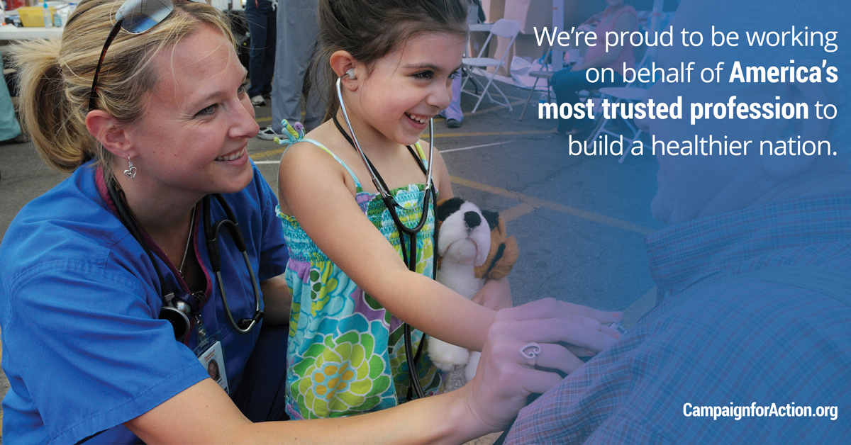
Draft Facebook post: Get involved with the [insert name of your state] Action Coalition and join us as we work to improve health and health care through nursing for [insert name of residents of your state, e.g. Floridians]! [insert link to your website.]
For Twitter:
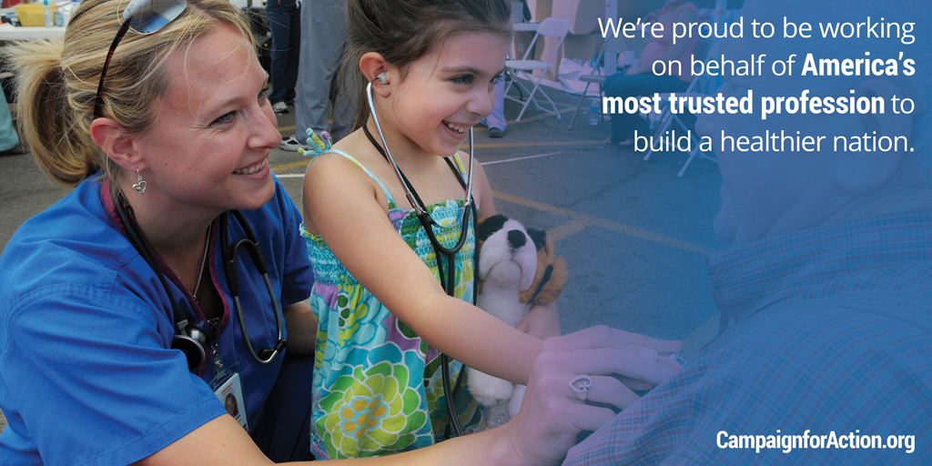
Draft Tweet: Join us as we work to improve health and health care through nursing for [insert name of residents of your state, e.g. Floridians]! [insert link to your website.]
Tweets for Action Coalitions
Below is a series of general tweets your Action Coalition can use or adapt for your state’s Nurses Week celebration. We realize all Action Coalitions have different priorities and goals during Nurses Week, so these are provided merely as a starting point. You are welcome to adapt and customize them for your own unique needs, or even better, write your own.
You are encouraged to include a website link in each tweet or Facebook post you share during Nurses Week---either to your Action Coalition’s website or to your Action Coalition’s page on the Campaign for Action website. Also, remember to use a link shortening website, such as bit.ly, to shorten the URL of your website when sharing it on social media.
- Happy #NursesWeek! Today and every day, we thank you for all that you do! [insert link to your website.]#FutureofNursing
- We salute our nation's 3.4 million nurses during [insert link to your website.] #‎NursesWeek‬! #FutureofNursing‬‬‬‬‬‬
‬‬
- From the front lines to the boardroom, #nurses lead at all levels! [insert link to your website.] #NursesWeek #FutureofNursing
‬‬‬
- This #NursesWeek, join a nationwide effort to improve health through nursing! [insert link to your website.] #NursesWeek #FutureofNursing
- Nurses are key to building a healthier America! [insert link to your website.] #NursesWeek #FutureofNursing
- #Nurses lead the way to healthier communities! [insert link to your website.] #NursesWeek #FutureofNursing
- #Nurses in [insert your state], join us in building healthier communities. [insert link to your website.] #NursesWeek #FutureofNursing.

- Remember to thank a #nurse this week. Our nation’s most trusted profession for 14 years in a row. [insert link to your website.] #NursesWeek
Reminder
In addition to these special images we’ve prepared, please be sure to visit the Campaign’s Facebook and Twitter pages during Nurses Week for new content and graphics that we’ll be rolling out during the week. We hope you will re-share and re-tweet this great content to your Action Coalition’s fans and followers.

Also, we will launch our new Campaign website on April 27, and we will use Nurses Week to drive lots of new eyes to our new digital home, www.CampaignforAction.org.

Need Help?
Have questions about Nurses Week? Need more information? Please email Meredith Courville for assistance.

