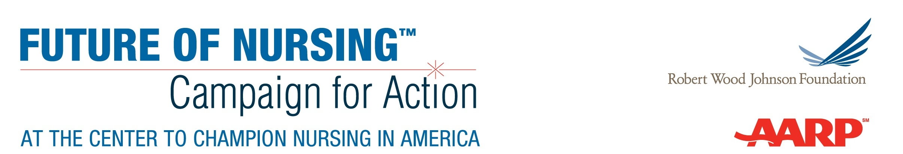

Core Pillars of Successful Fundraising

Building a Successful Fundraising Operation
A successful fundraising operation depends on four core pillars working in tandem to support both day-to-day fundraising activity as well as overarching planning, goals and strategy. For Action Coalitions raising funds in support of the Future of Nursing: Campaign for Action, these four elements are described as follows:
- Donor Engagement: The Action Coalition will need enthusiastic, reliable donor and funder support to meet its fundraising goals. Whether that support comes from a broad base of grassroots supporters or from a smaller cohort of high-capacity donors and funders—or ideally, a combination of these—the Action Coalition will need to put in place strategies for donor-centered fundraising that help supporters feel engaged and fulfilled by their contributions.
- Case for Support: The Action Coalition’s vision and impact must be clearly and compellingly articulated, with a strong rationale for the role of philanthropy in helping the Action Coalition achieve that vision, both at the state level and in the context of the broader Campaign for Action. A successful case for support will demonstrate how supporters’ funding will be used and will frame messaging as a partnership between the Action Coalition and the donor in meeting broader societal needs—rather than fulfilling a need within the Action Coalition itself.
- Leadership: A successful fundraising program requires visible leaders willing to dedicate time—and their own philanthropic support—to advance fundraising activity. This begins with top-level volunteers and staff (if staff positions exist) and includes involvement in actively soliciting gifts, advocating for the Action Coalition, and making connections with potential donors. This requires clearly defined roles for volunteers and volunteer groups as well as mechanisms for supporting and coordinating this activity.
- Internal Operations: Whether the Action Coalition has dedicated staff or not, internal operations must be in place to handle gift processing, tracking and reporting; volunteer organization and coordination; prospect research and tracking; fundraising planning; and other similar “behind-the-scenes” work.
The graphic on the following page details the fundamental questions that underlie each of these pillars.
Supporting materials developed through the fundraising pilot program provide additional resources for addressing these questions and advancing Action Coalitions’ work in each of these core areas.

- What level of philanthropic support do we need to raise and for what purposes?
- What level of philanthropic support is feasible to raise?
- What activities and investments are necessary to reach that goal?

- What are the most effective ways to identify and engage new prospects?
- What activities will motivate continued and upgraded gifts from current supporters?

- What aspects of our work and vision will inspire the greatest philanthropic support and have the greatest impact on our mission?
- How will we communicate our goals and vision most effectively to different constituencies?

- Which volunteer(s) or group will serve as the primary champions for fundraising within our Action Coalition?
- What is the most effective way to engage and support other volunteers in advancing our fundraising work?

- What (if any) staffing will be necessary to support our fundraising program?
- What systems do we need to have in place to organize and accurately track our work?

A Framework for Fundraising Success

